Data Structures and Algorithms

# **Function**

Whenever there is a return statement being executed the function stops executing after the return statement is executed.

# **Recursion**

1. When a function call calls itself.
2. When a specified condition is met

**Example to understand point 1: -**

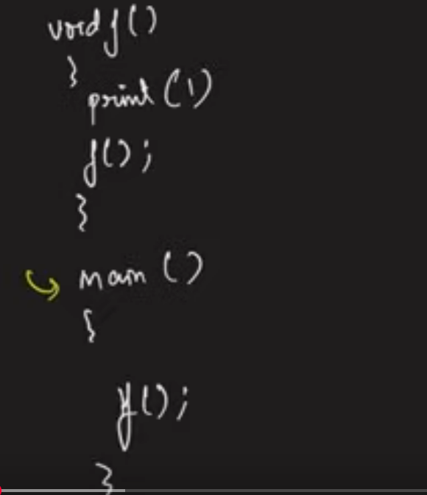

**Running of the program:**

1. Program comes to main i.e., the execution
2. Whenever a function is called it straight away goes and calls the function. In the above example function ‘f’ is called inside main, so it straight away goes and calls the function ‘f’.
3. The function ‘f’ executes the line `print(1)`. So, in the output screen 1 is printed.
4. After step 3, the next line is executed which states calling of the self-function ‘f’, which means it is calling the same function in memory.
5. The function ‘f’ executes the line `print(1)`. So, in the output screen 1 is printed.
6. After step 5, the next line is executed which states calling of the self-function ‘f’, which means it is calling the same function in memory. It goes on again and again everyday as there is no stop condition which says to stop calling the self again.
7. The above is an infinite recursion or non-ending recursion as there is no specified condition mentioned to stop it.
8. In the program run, it prints many 1’s and then it ran out of memory. This is called Stack Overflow.

**Example to understand point 2: -**

We will have a condition where we will stop calling the function that condition is know as base condition.

|  |  |
| --- | --- |
|  |  |



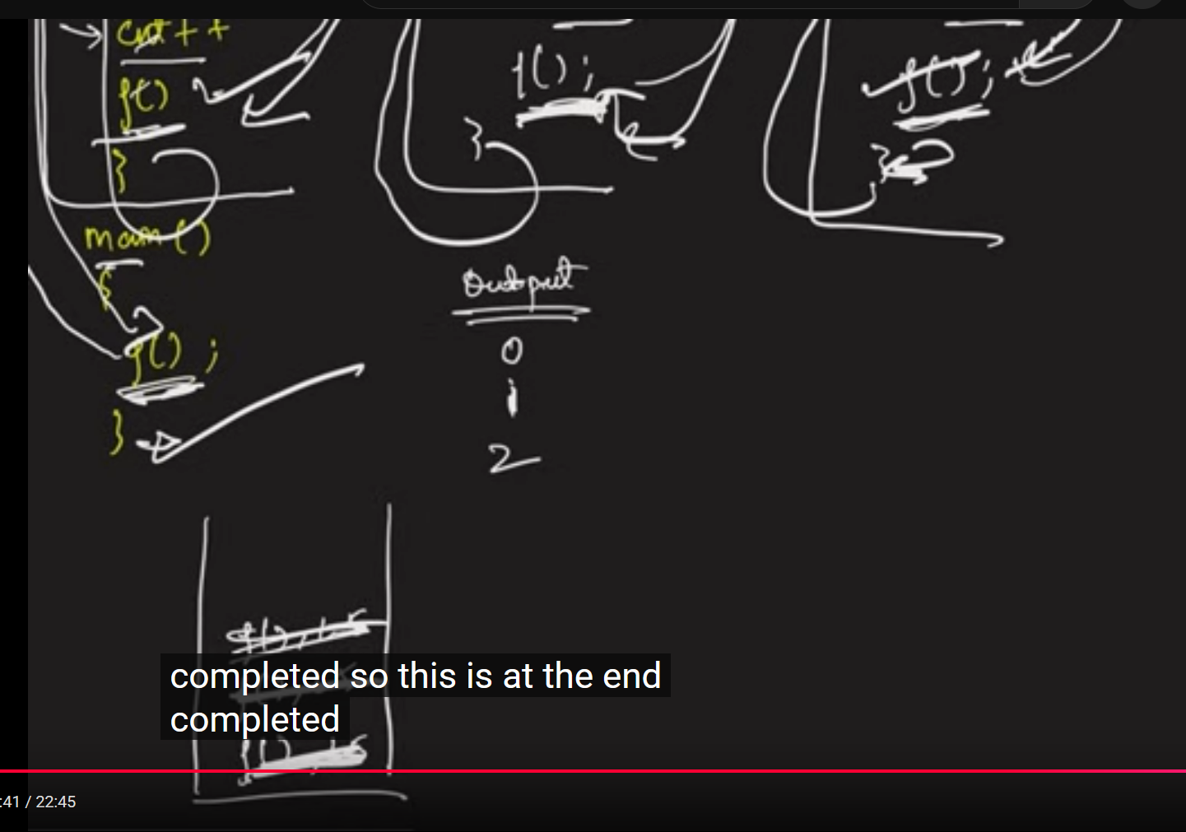

## **Recursion Tree**

To explain the tutor wrote the entire function again and again which is tedious. So the whole representation is truncated into a recursion tree. Instead of writing the entire function we represented it in terms of its name i.e., the entire function represented in smaller representation. This is called a Recursion Tree.

# **Stack Overflow Error**

A function is completed when the last line is successfully executed. But the above example has not been completely executed as the function called another function. As the stack has a particular memory space, it cannot keep on piling up all the incomplete function calls in the memory leading to memory becoming full. This is when segmentation fault happens. This is commonly known as Stack Overflow. Another definition is when there are numerous function calls waiting due to recursion is called Stack Overflow. This is why we don’t write a code which has infinite recursion calls as we end up with Stack Overflow.

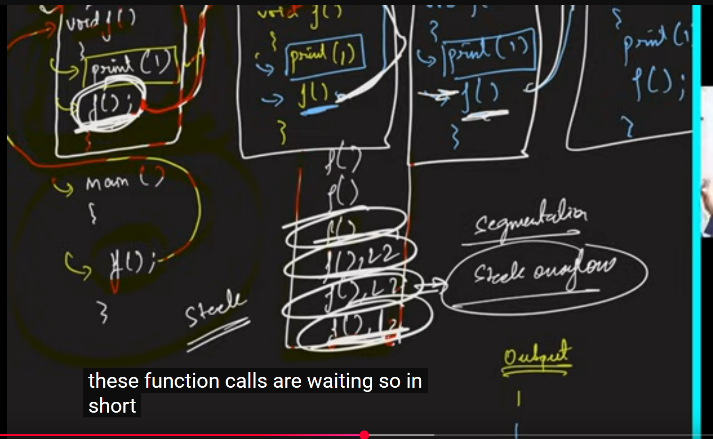

## **Stack Space (Auxiliary Space)**

The space where the remaining non-executed or not completed functions are stored. It is also called Auxiliary space.

# **Examples**

## Example-1: Printing name n times using recursion

Generic way is to use ‘for’ loop and print the name n times. Here solving using recursion way, we are going to use change of parameters concept.

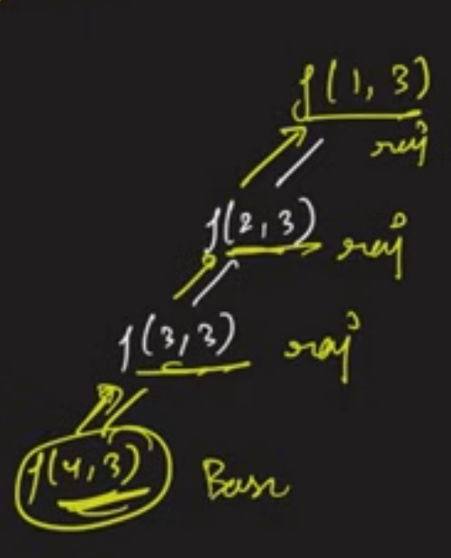

The time complexity is O(n) as we are calling n functions. The logic inside the function will take only O(1) times. For Space Complexity we assume the Stack Space is being used, it is O(n). This Space complexity being used here is hypothetical, we are not using array, we are using the computer’s internal memory which is the stack space.

## Example-2: Printing numbers from 1 to N using recursion

The implementation is similar to the previous problem only difference is we will print the number instead of the name.

## Example-3: Printing numbers from N to 1 using recursion

The implementation is similar to the previous problem the only differences are: -

* The base condition will be index < 1 instead of index < numberOfTimes.
* The method definition is printingName(int index) instead of printingName(int index, int numberOfTimes).

## Example-4: Printing the numbers from 1 to N by backtracking using recursion

Want to print from 1 to N numbers but should not use ‘i+1’ i.e., the recursion call starts from ‘(N, N)’. Will be understanding backtracking. Refer the code in the repository [AlgorithmsAndDataStructures](https://github.com/Phanindra08/AlgorithmsAndDataStructures) under the recursion package.

In order to print in ascending order, it is not mandatory that we start from 1. We can start from the back and we can print the number after the function call. By doing this we made sure that the last guy has been executed first. If the print statement is after the function call, then the print statement gets executed only if the base case is true.

**Recursion Tree for the above problem is:**

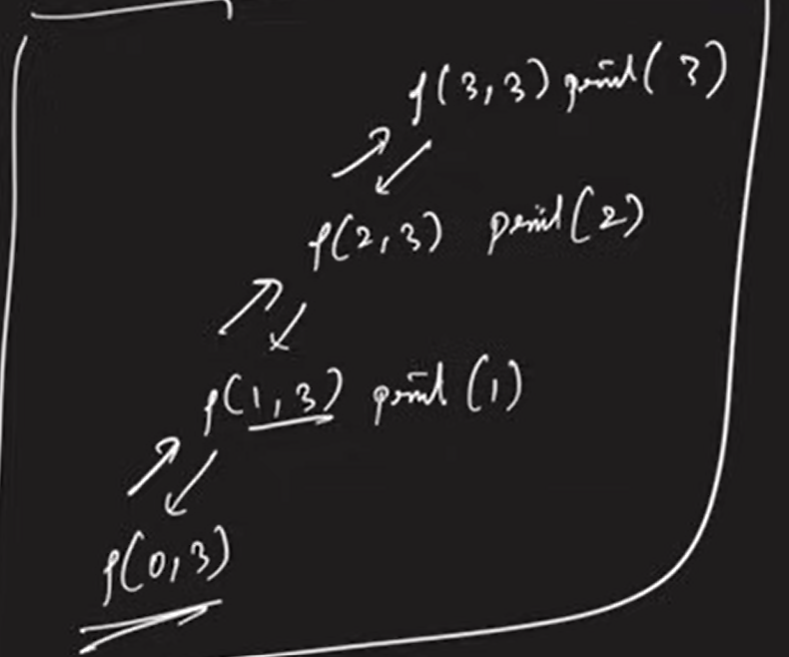

## Example-5: Printing the numbers from N to 1 by backtracking using recursion

Want to print from N to 1 numbers but should not use ‘i-1’ i.e., the recursion call starts from ‘(1, N)’. Will be understanding backtracking. Refer the code in the repository [AlgorithmsAndDataStructures](https://github.com/Phanindra08/AlgorithmsAndDataStructures) under the recursion package.

In order to print in descending order, it is not mandatory that we start from N. We can start from the 1 and we can print the number after the function call. By doing this we made sure that the last guy has been executed first. If the print statement is after the function call, then the print statement gets executed only if the base case is true.

## Example-6: Sum of first n numbers

The above problem can be solved using simple for loop but here we solve it using recursion. Will solve it in 2 ways: - parameterized way (Solve it using parameter) and the functional way (the function returns the answer).

### Recursion Tree for Parameterized Way

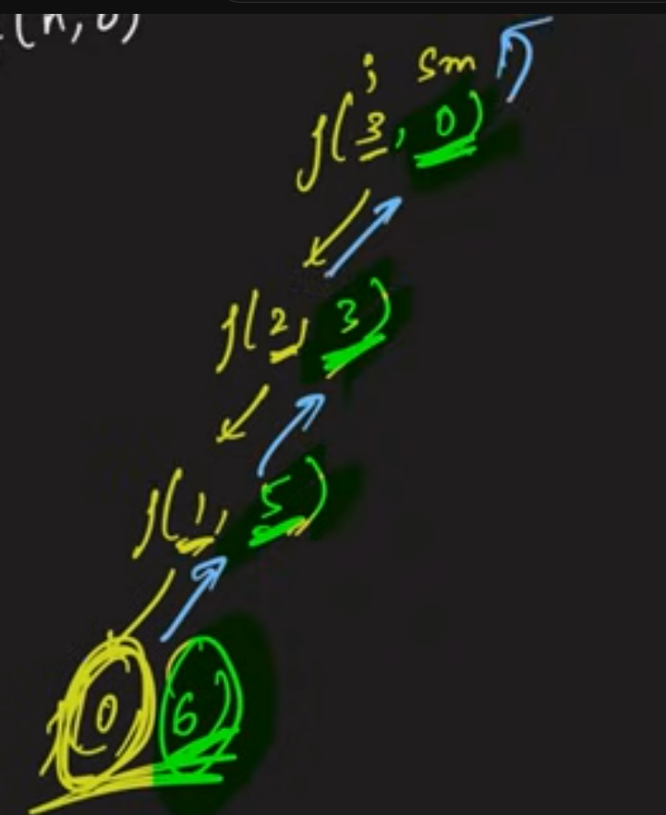

### Functional Way

Refer the code in the repository [AlgorithmsAndDataStructures](https://github.com/Phanindra08/AlgorithmsAndDataStructures) under the recursion package.

The time complexity for the above problem is O(n). As we don’t take a lot of time inside these functions the number of function calls is equal to the time complexity for the function.

The space complexity there will be ‘n’ number of functions waiting in the stack to be completed. So it is the stack space.

## Example-7: Factorial of a number

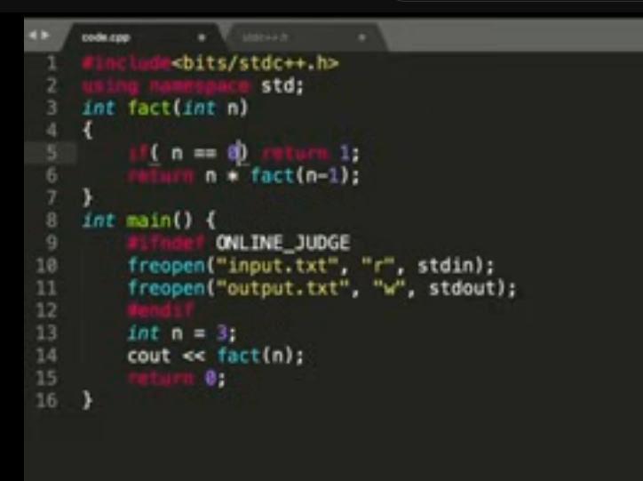

## Example-8: Reversing an Array

**Note:**

* Arrays are passed using reference.
* In recursion we should understand which task does recursion needs to do. In the example-8 recursion has to do swapping.

Refer the code in the repository [AlgorithmsAndDataStructures](https://github.com/Phanindra08/AlgorithmsAndDataStructures) under the recursion package.

### Example-9: Palindrome

Palindrome is a string on reversal reads the same.

The time complexity is O(n/2) as we are going only till the half. The Space complexity will be only the auxiliary stack space, hence O(n/2).

## **Multiple recursion calls**

### Example-1: Fibonacci Number

The definition of Fibonacci number is the addition of the last and last but one number. The first couple of Fibonacci numbers are 0 and 1.

**Logic for Simple linear version using iterative ‘for’ loop:**

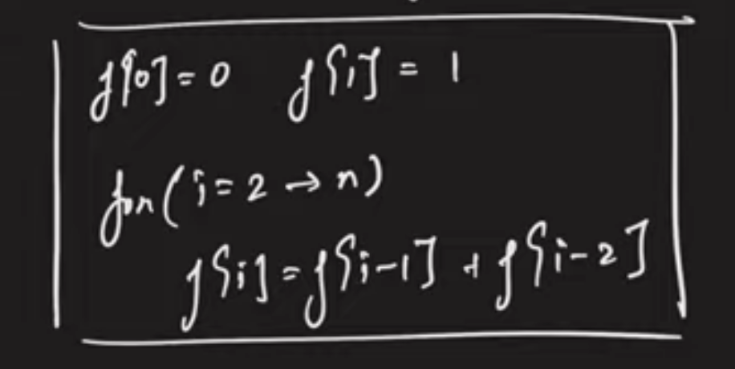

**Using Recursion:**

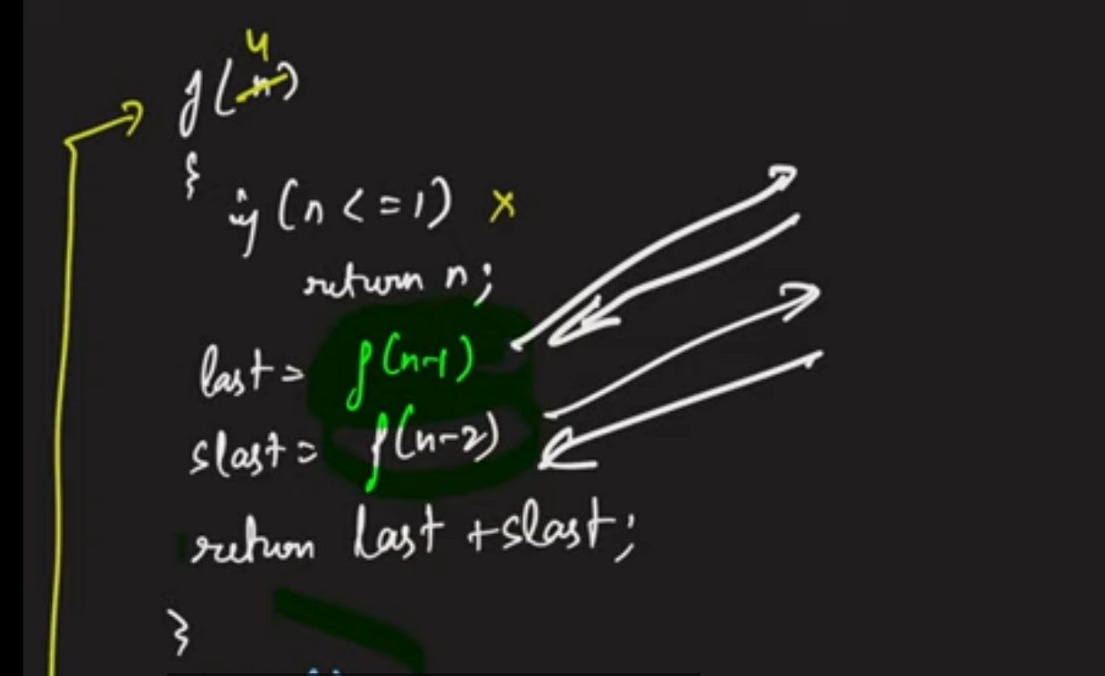

The two recursion calls that are present above will not run simultaneously. They will be called line by line. Which recursion call is made first it will be executed first and then the next one will be called.

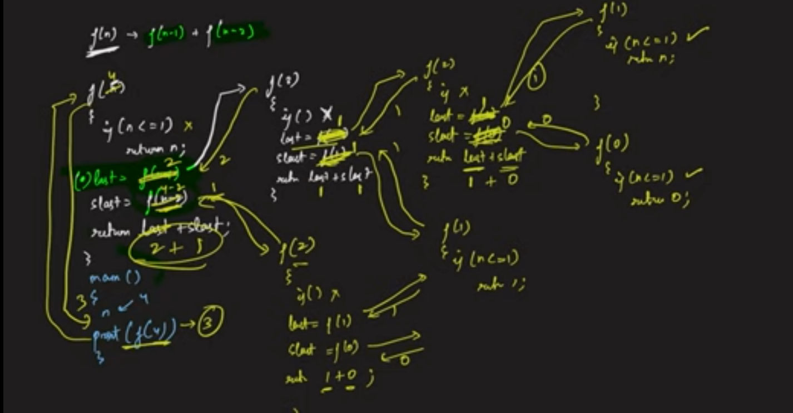

The above picture is the way how the entire recursion calls will happen. Always remember if there are multiple recursion calls, once one recursion call ends then the next one gets started. That is how recursion call works. The next recursion will never execute before ending the previous one.

**Recursion Tree for the above problem:**

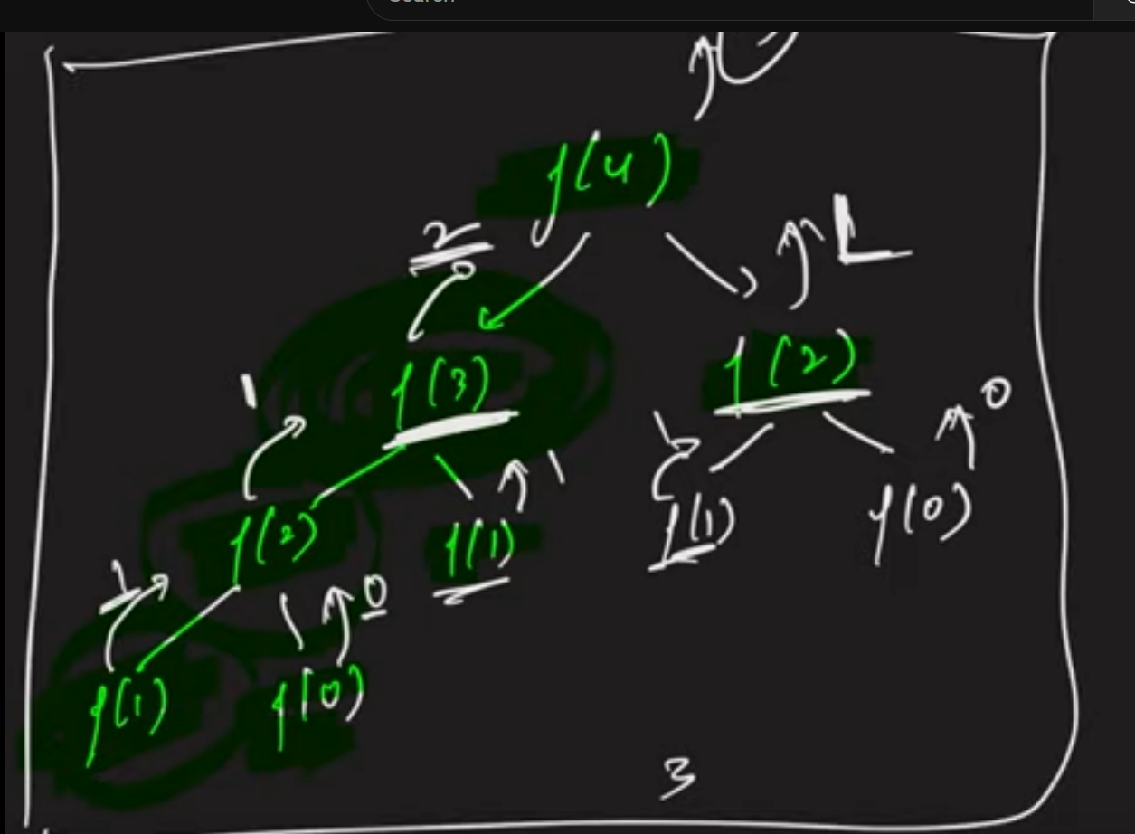

The time complexity is O(2^n). It is not exactly 2^n as for any call you called the previous and last but one call. The last but one will be one less than previous. So, it is nearly 2^n which is exponential. FYI, the recursion call is not unidirectional, it is bidirectional.

### Example-9: Print all the subsequences

#### **Subsequence:**

A contagious or non-contagious sequences, which follows an order is called subsequence. Subarray is contagious and subarrays can be subsequence.

**Example:** Subsequences of the array [3, 1, 2] are [[], [3], [1], [2], [3, 1], [3, 2], [1, 2], [3, 1, 2]]. Among the above the subsequence [3, 2] is non-contagious and the remaining subsequences are contagious. [3, 2, 1] is not subsequence as it is not following the order. The order for the above array is 3 has to be before 1 and 1 has to be before 2. Apart from the subsequence [3, 2] remaining are subarrays. For the array of size 3 there are total 8 subsequences.

The printing of all the subsequences can be done using a famous algorithm powerset.

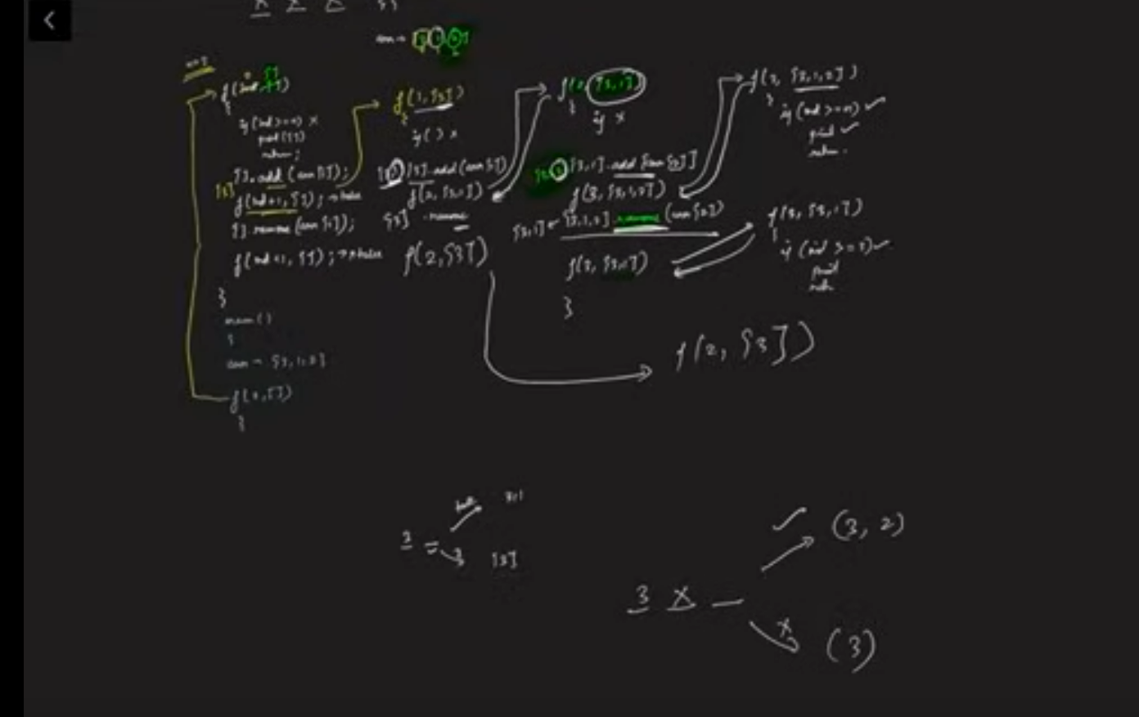

**Representing in the form of Recursion Tree:**

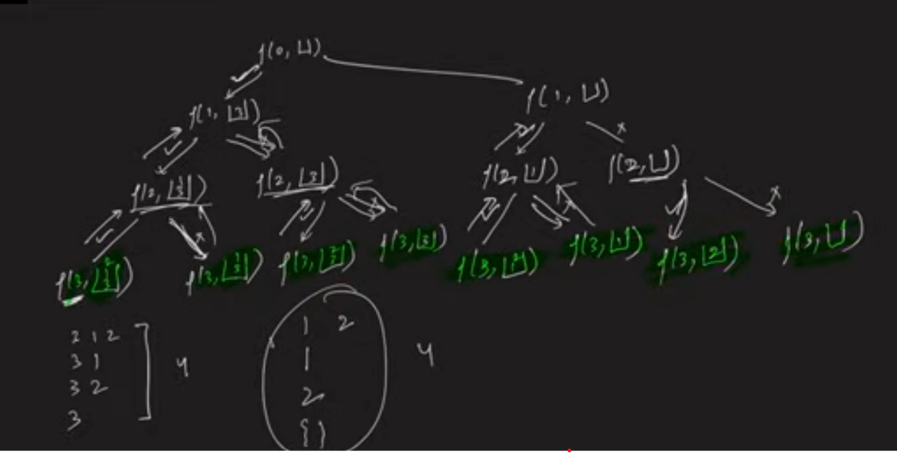

The f(1, [3]) was made previously, the number ‘3’ has to be removed from the array before making the f(1, []) method call.

The time complexity is: for every index there are couple of options, as for every index we have 2 options the time complexity is O(2^n). For every subsequence we are using for loop to print it so the printing takes O(n), though it is not n for every subsequence printing but overall, it is taking a time of n. In total O(n * 2^n) is the time complexity.

The space complexity is the maximum number of recursions that will wait in the stack space are 3 for the above example. So, O(n) is the space complexity.

### Example-10: Print all the subsequences whose sum is k

We are going to use the technique of take and not take to solve this problem.

**Recursion Tree**

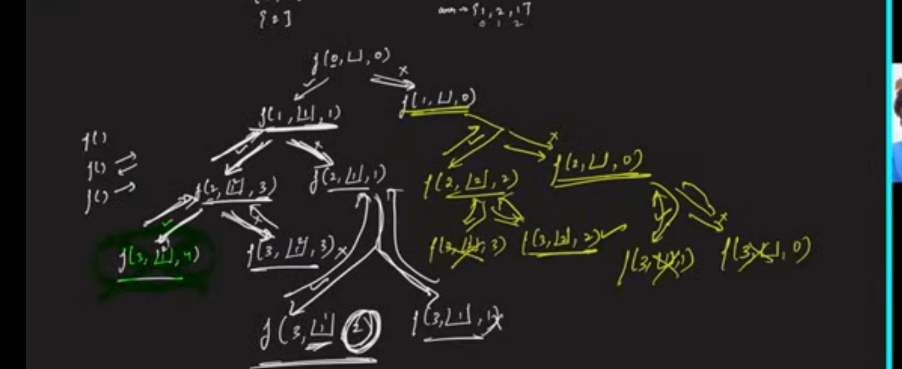

## Functional Methods

It is a pattern which should be always kept in the brain. If the function call is able to tell us that a subsequence has been found then there is no need to call any further function calls as we need only one subsequence to be printed. This is the technique to print one subsequence.

### Example-1: Print any one subsequence whose sum is k

Can solve the problem using global variable as shown below:

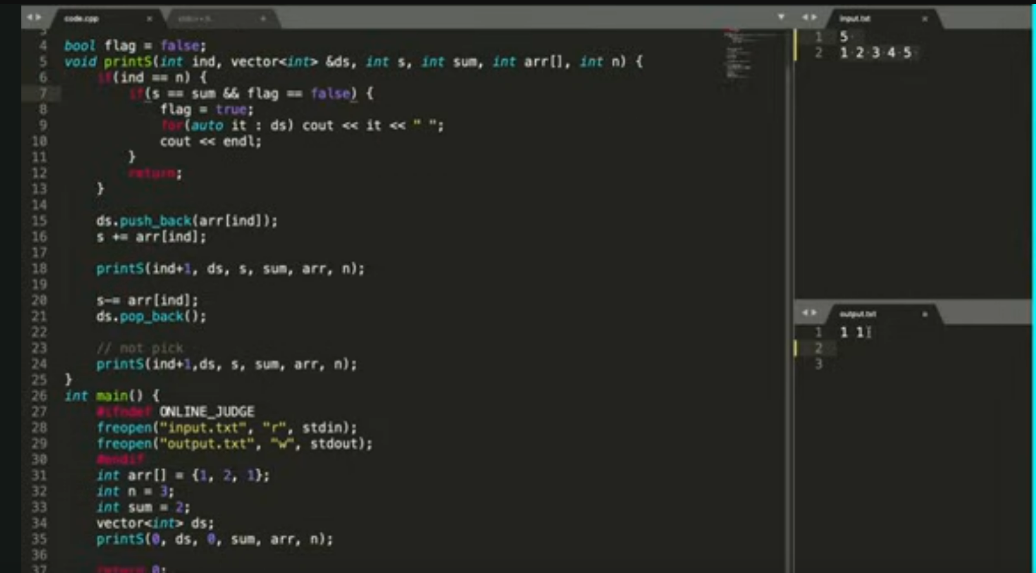

But the above approach is not preferred and it is not recommended to use global variables. To solve the above problem, we can use the functional methods pattern. Remember, to avoid future recursion calls if getting an answer.

### Example-2: Print the count of subsequences whose sum is k

Refer the code in the repository [AlgorithmsAndDataStructures](https://github.com/Phanindra08/AlgorithmsAndDataStructures) under the recursion package. If there are only two recursion calls use the logic to the left in the below picture. If there are n recursion calls, we can solve it using the logic to the right in the below picture. We kept on adding up the subsequences that matched the sum by recursively going till the end, is the reasons behind the technique being successful.

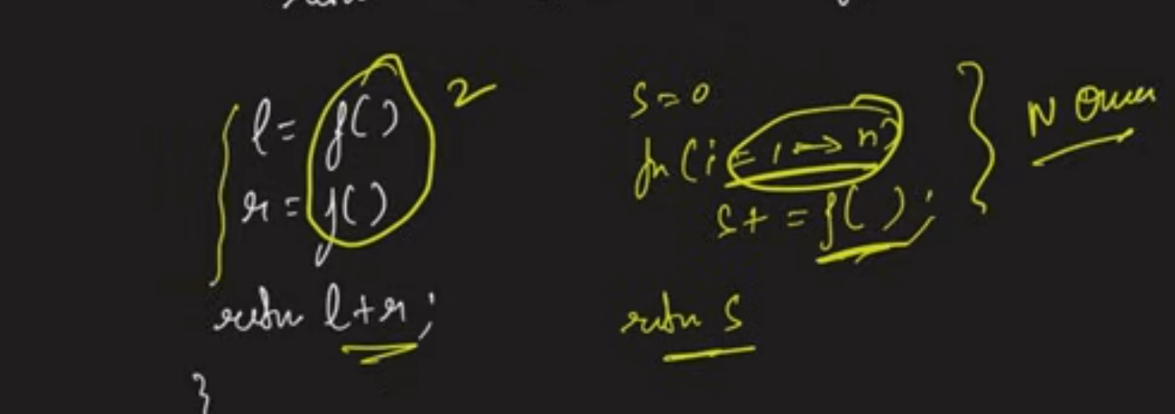

**Time Complexity:** As we have two options for every element in the array the time complexity is O(2^n).

The above time complexity can be reduced using the below base case provided all the elements in the array are positive values.

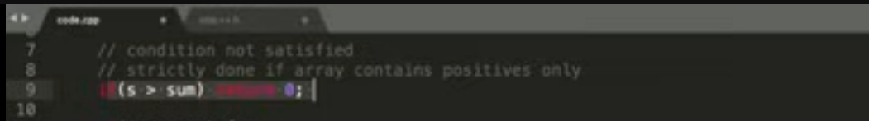

# **Dynamic Programming**

There are two ways people tend to solve it.

1. **Tabulation Way: -** Bottom-up Dynamic Programming. Bottom-up doesn’t mean we are going to start from zero till top. It can be vice versa as well. But as the name suggests it is a bottom-up approach of solving the problem.
2. **Memoization Way: -** Top-down Dynamic Programming. Top-down doesn’t mean we are going to start from top till zero. It can be vice versa as well, depends on our implementation skills. But as the name suggests it is a bottom-up approach of solving the problem.

# Sorting Algorithms

The algorithm which sorts a given data structure.

## Bubble Sort

**Time complexity:** O(n^2).

## Insertion Sort

**Time complexity:** O(n^2).

## Selection Sort

**Time complexity:** O(n^2).

## Merge Sort

### Algorithm Explanation

Algorithm means Divide and Conquer.

**Example:**

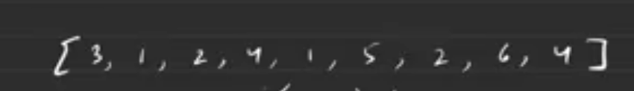

Dividing the above array into two parts. As the length of above array is 9, we can divide it either as array of sizes 5 and 4 or 4 and 5. We will divide it into bigger and then smaller but make sure to follow same pattern throughout the algorithm. Algorithm divides the array hypothetically. We will divide the array till we get a single number and then follow the second half of the algorithm which is merge.

While diving we will get two hypothetical arrays of one number each at one point. We will make it into a single array by merging it in a sorted way. Then the left and right arrays will be sorted by itself and we will merge them into single array in a sorted way. The resultant array is sorted after performing both divide and merge on all parts of the array.

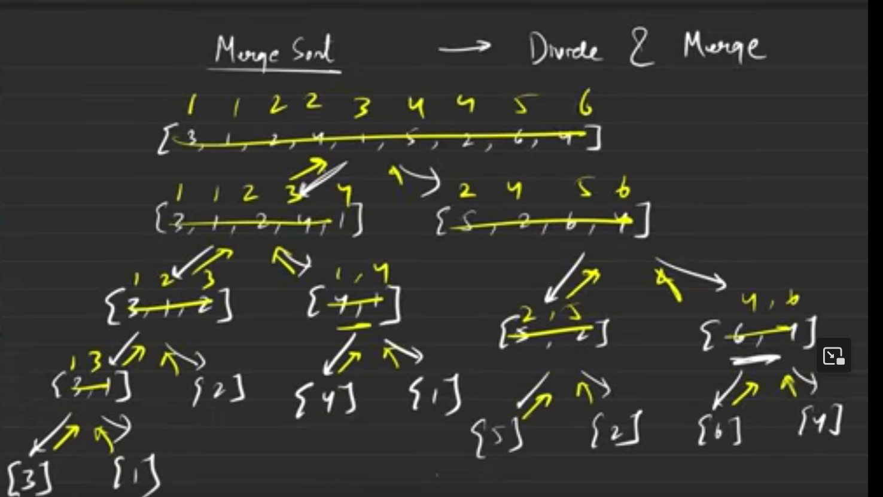

### Pseudocode

It doesn’t make sense to keep on diving the array. Hence, instead of breaking down the array into new arrays, we will play around with indexes. We will refer to the starting point of the hypothetical array as low and ending of the hypothetical array as high. Instead of dividing the array, we are passing on the indexes to the sort the arrays.

**Time complexity:** O(nlogn). This has a better time complexity compared to bubble sort, insertion sort and selection sort. O(nlogn) is the best, average and worst time complexity of this algorithm.

As the division happens approximately logarithmic time i.e., near about logarithmic time and then merge should happen. If we take the extreme case for a merging the arrays of size 3 and 2 -> need 5 steps minimum which is the length of the array -> So the worst case is O(n).

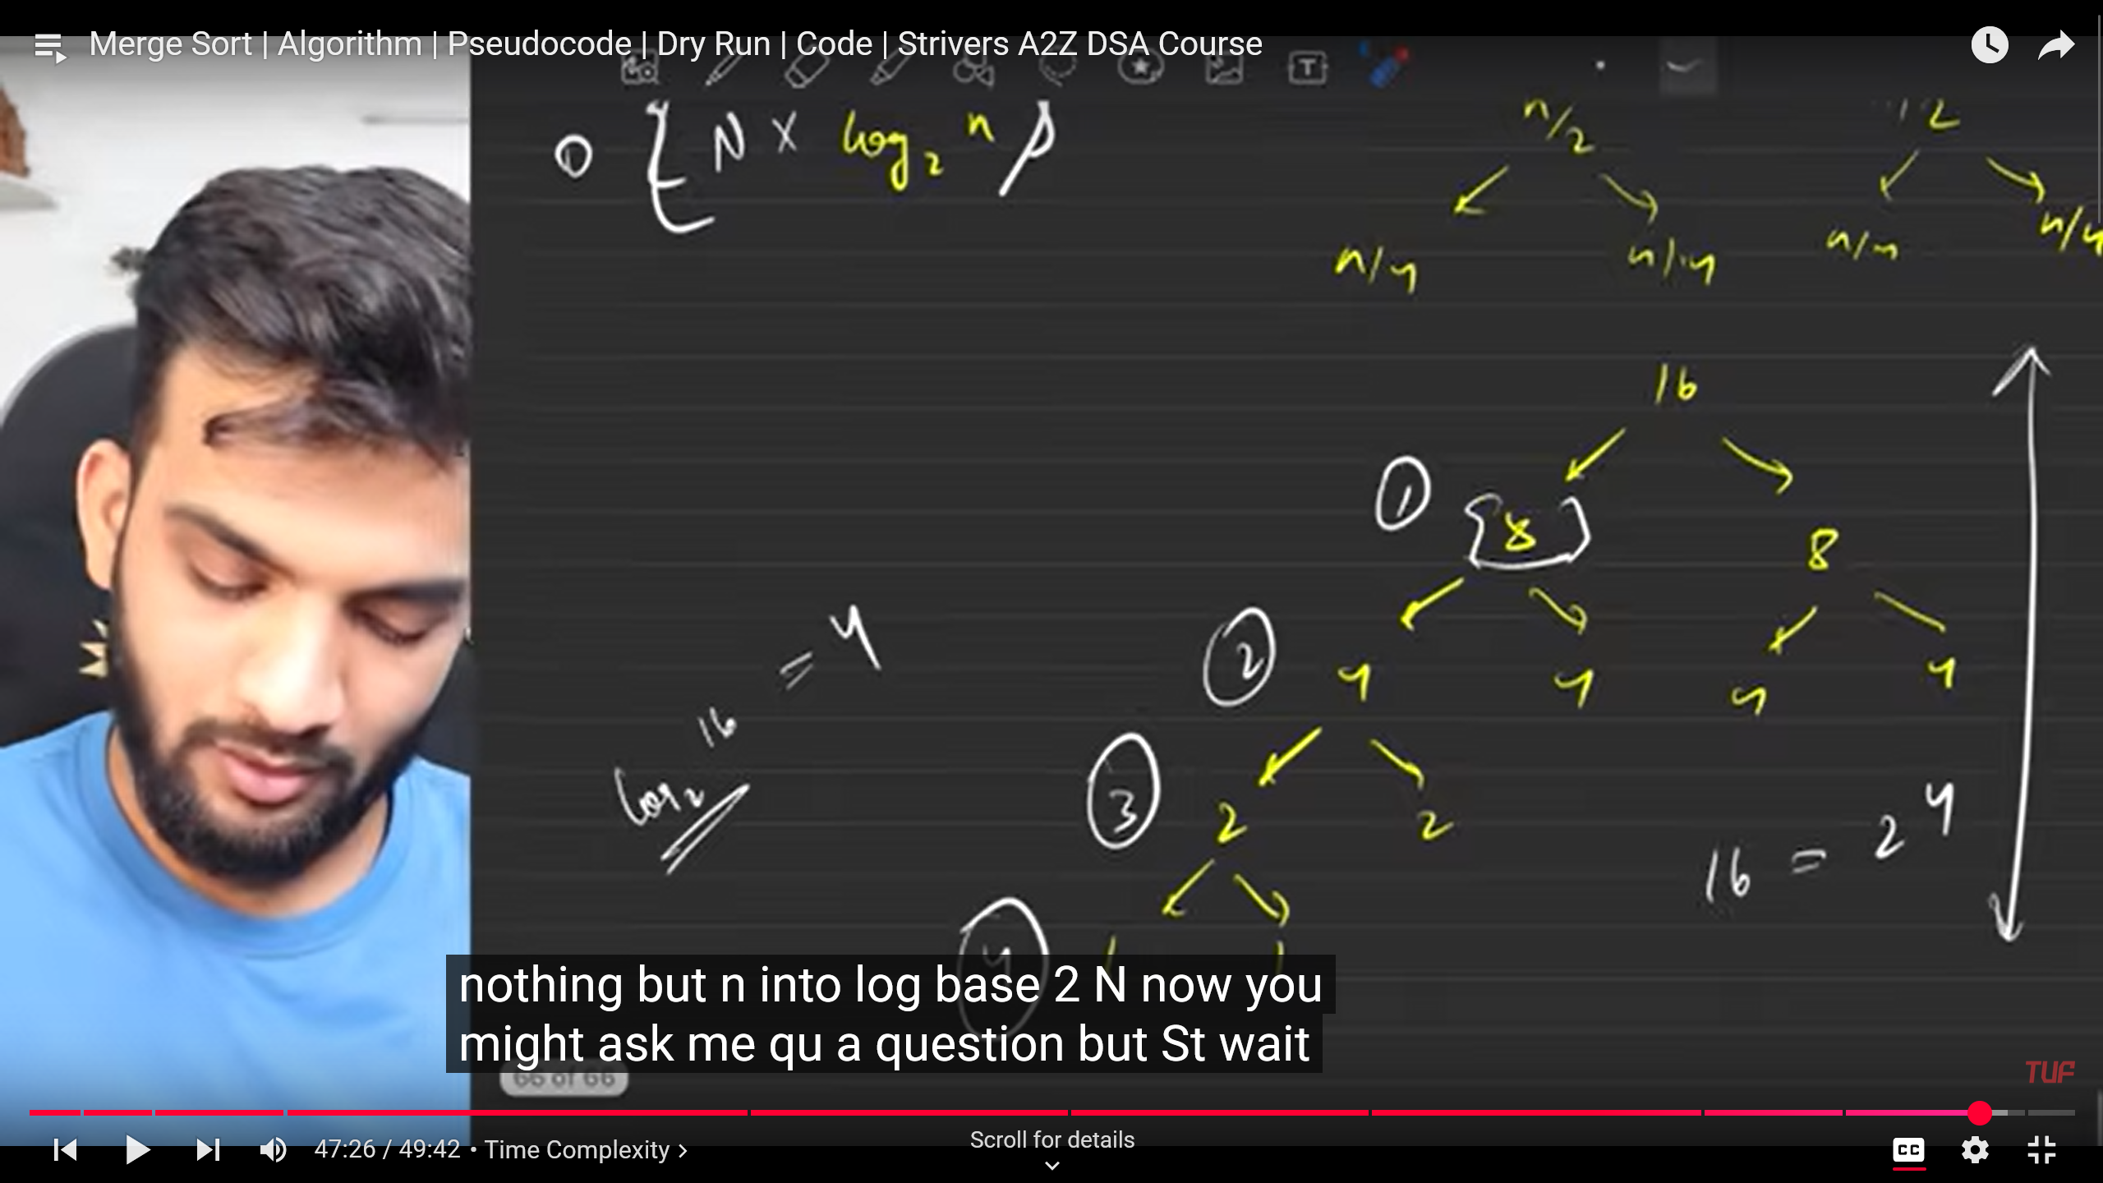

**Space Complexity:**

During divide we are not using any extra space apart from indexes. But during merge we are having a temporary array which at worst case takes n. Hence space complexity is O(n).

## Quick Sort

### Algorithm Explanation

Because of Space Complexity quick sort is slightly better than Merge Sort.

Pick a pivot which can be first element or the last element or the middle element or any random element in the array of our choice. Picking the pivot as the first element in the array. Pick the pivot and place it in the correct place in the array. Then pick up another element and place it in the correct place and soon till the entire array is sorted.

While placing the pivot in the correct place, place the smaller on the left and larger on the right. Reason behind this intuition is once pivot is in the correct place, elements smaller than pivot should be to the left and the elements larger than the pivot should be to the right.

Repeat the above two steps again and again till the entire array is sorted i.e., when the array to the left or right is having only one element then we don’t need to do anything as the array with one element is sorted by itself.

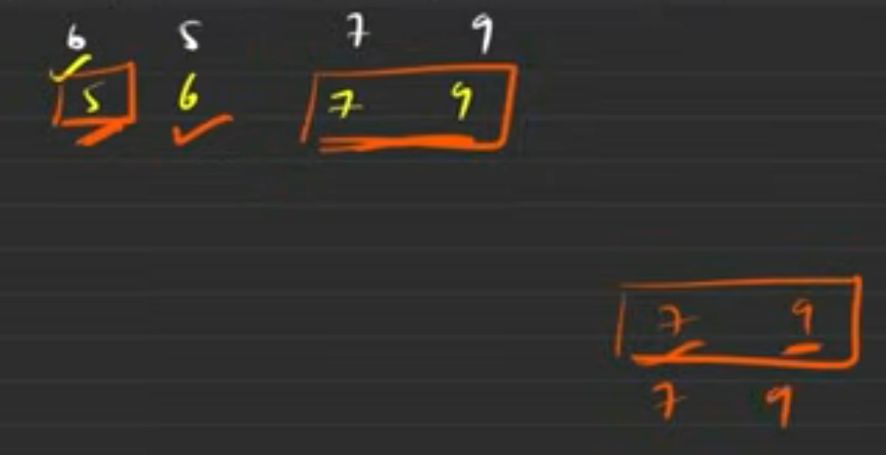

### Pseudocode

We are not going to create new arrays, we will use the concept of low and high which is used in the merge sort i.e., will use pointer to consider that the left array is from which index to which index and the right array is from which index to which index.

The index where the pivot is placed in the array is called partition index, because the array to the left and the right of partition index is not in the correct order. But the partition index is at the correct place in the sorted array.

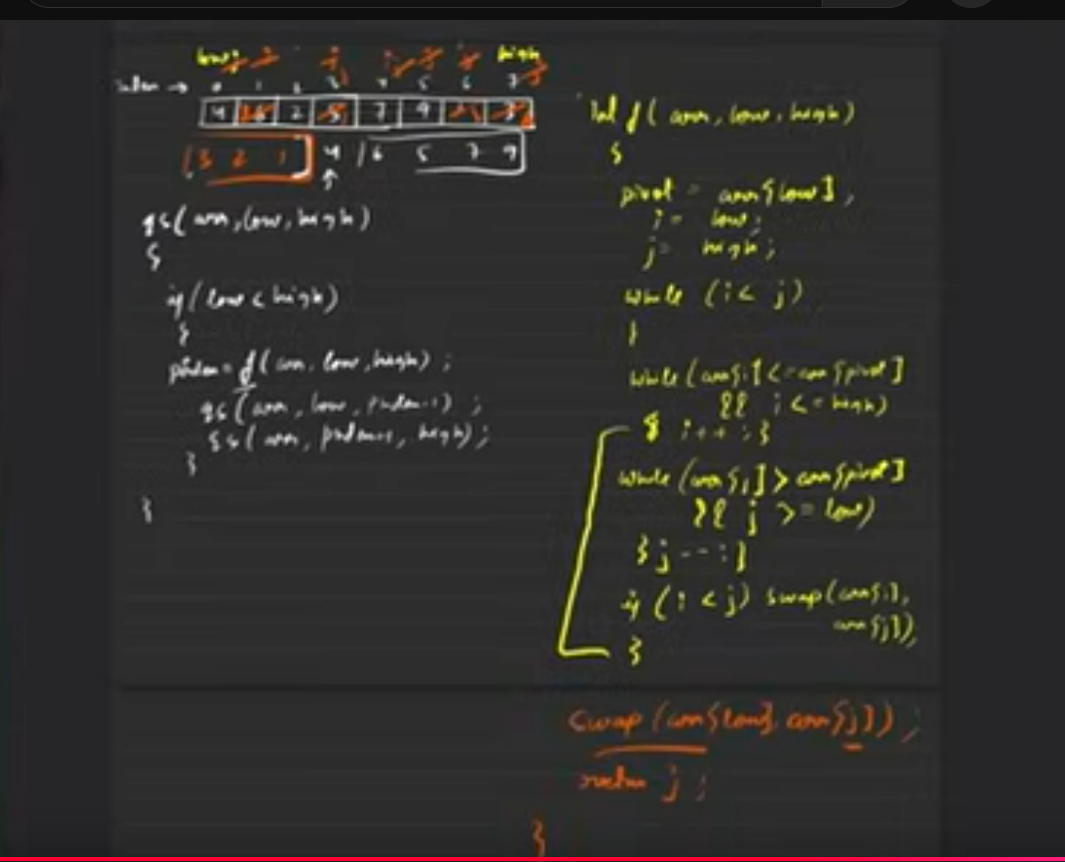

Have to decide whether the element equal to the pivot will be in the left part of the array or the right part of the array.

It is a divide and conquer algorithm because we are kind of dividing the array and when dividing every part is getting solved by itself hence divide, and then conquer which is solving.

**Time Complexity:** O(nlogn) same as Merge Sort as we are splitting the array every time into two halves. They are not getting split equally but they are getting into couple of halves. The height of the tree is O(logn).

In the partition function we are going from low to high for the left pointer and high to low for the right pointer. Hence, O(n).

**Space Complexity:** O(1). It uses temporary stack space we are not considering the temporary stack space but does not use any temporary array.